IT5010D: Assignment #1

Practical Project – Case Study

Report

|  |  |
| --- | --- |
| **Student Name:** | Nilesh Raj |
| **Student ID:** | 20220999 |
| **Due Date:** | 18th November, 2022 |

1

**Contents**

1. Executive Summary 2

2. Network Diagram 3

3. Quotation 3

4. Communication Channel Security 4

5. Support Call Prioritisation 5

7. References 5

# Executive Summary

We are thrilled and excited to hear our organization is expanding IT help desk to a new site in Auckland. In order to continue with exceptional support to our valued customers, we would replicate network structure of Wellington office. For the start Auckland office will be equipped with four (4) workstations (Laptop) and a network printer. The two sites will communicate to each other over a VPN connection secured using IPsec technology.

# Network Diagram

|  |
| --- |
|  |

# Quotation

|  |  |  |  |
| --- | --- | --- | --- |
| **Items** | **Cost** | **C. Rationale and Justification for each component** | **Reference**  APA (7th ed.) format. E.g., (Rasmussen, 2021, para. 2) |
| **A.** Hardware/Software Components |  |  |  |
| Network devices | $428 | 24 ports available for future upgrades | (PB Tech,2023, Webstore)  <https://www.pbtech.co.nz/product/SWHNGR64010/NETGEAR-24-Port-Gigabit-Ethernet-Smart-Switch-GS72> |
| **B.** Computing equipment and network components | $4715 | Laptops- For portability and remote working | (PB Tech,2023, Webstore)  <https://www.pbtech.co.nz/product/NBKLEN150200/Lenovo-V15-G2-Business-Laptop-156-FHD-Intel-i5-113> |
| Servers | $4,349 | For VPN, File and Application | (PB Tech,2023, Webstore)  <https://www.pbtech.co.nz/build/49400> |
| Infrastructure | $2196  $1676 | Chairs and Table | (Warehouse Stationery,2023, Webstore) |
| Printers | $2961 | A3 color Laser network printer | (PB Tech,2023, Webstore)  <https://www.pbtech.co.nz/product/PTROKI03748/Oki-MC853DN-A3-Printer-23ppm-1200-x-600-dpi-Colour> |
| Related hardware | $263 | Network Cable Supports faster speed of 10GB | (PB Tech,2023, Webstore)  <https://www.pbtech.co.nz/product/CABCXT945000/Cruxtec-50m-Cat7-Ethernet-Cable---Blue-Color----10> |
| Software | $1368  $955 | Windows Server 2022 and Office Suite for word processing, email, spreadsheet | (PB Tech,2023, Webstore)  <https://www.pbtech.co.nz/product/OSYMSO08328/Microsoft-Windows-Server-2022-Standard-16-Core-OEI>  <https://www.pbtech.co.nz/product/EPYNZMSOESD44/Microsoft-365-Business-Standard-12-months-Subscrip> |
| Accessories | $1007 | Monitor for multitasking | (PB Tech,2023, Webstore)  <https://www.pbtech.co.nz/product/MONLEN322240/Lenovo-ThinkVision-S24E-20-238-FHD-Monitor-1920x10> |
| Security protocols | Upon Request | Endpoint Security platform | (Broadcom,2023, Webstore)  <https://www.broadcom.com/products/cybersecurity/endpoint/end-user> |

Link for Chairs

<https://www.warehousestationery.co.nz/product/W2540894.html#prefn1=brand&prefv1=Jasper+J&prefn2=subclassCode&prefv2=Office+Chairs&srule=price-high-low&start=1>

Link for Table

<https://www.warehousestationery.co.nz/product/W2243770.html>

# Communication Channel Security

A site-to-site VPN connection will be implemented. In this connection type data is encrypted from one VPN gateway to another gateway, providing a secure link between both sites over the internet. This would enable both sites to share resources such as documents and other types of data over the secure VPN link.

The connection will be secured using IPsec. This technology establishes an IPsec tunnel between two sites on a public network and using encryption and authentication algorithms to ensure the security of VPN connections.

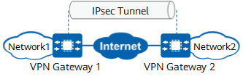

Figure Reference: <https://info.support.huawei.com/info-finder/encyclopedia/en/IPsec.html>

In the following figure, the IPsec sender uses the encryption algorithm and encryption key to encrypt an IP packet, that is, it encapsulates the original data. Then the sender and receiver use the same authentication algorithm and authentication key to process the encrypted packets to obtain the integrity check value (ICV). If the ICVs obtained at both ends are the same, the packet is not tampered with during transmission, and the receiver decrypts the packet. If the ICVs are different, the receiver discards the packet.

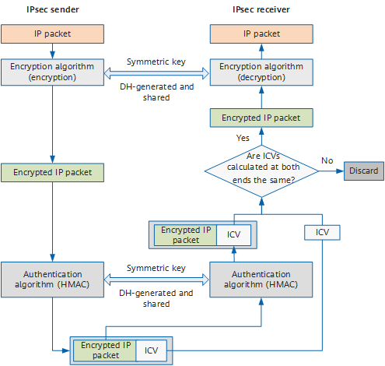

Figure Reference <https://info.support.huawei.com/info-finder/encyclopedia/en/IPsec.html>

# Support Call Prioritization

There will use four priority levels: URGENT, HIGH, MEDIUM and LOW.

|  |  |  |
| --- | --- | --- |
| **LEVEL** |  | Description |
| Urgent | Business Halted | Emergency affecting multiple users such as critical application is down and customers revenue or product development in jeopardy. |
| High | Business Impacted | Affecting multiple users where mission critical application is partially unavailable or reduction in productivity. |
| Medium | Non-Critical | Issues that are not so critical such as one of network printers |
| Low | Service or Training Request | Like planned upgrades or training with lead times |

1. **Summary**

There is lots to take away from this project. The key learnings are security technology such as IPsec that is used to secure a VPN connection between two sites and drafting network diagram that suites the business model. Understanding the scenario and then adding correct hardware/software was overwhelming but rewarding as well.

# References

# (Huawei,2023, Website)

<https://info.support.huawei.com/info-finder/encyclopedia/en/IPsec.html>